**PROJECT J. March 2023.**

Performed Exploratory testing on Jumia NG website.

Task : **EXPLORATORY TESTING & REPORTING.**

We use exploratory testing to evaluate the website like a user would, navigating through the website.

I produced an exploratory testing report in Microsoft Word and Excel format on the website:

https://www.jumia.com.ng

I documented issues that may hinder a user’s experience on the website.

The report included amongst others:

1. Steps to recreate the issue found
2. Device/browser affected
3. Date and time of occurrence
4. Screenshot of issue (where appropriate)

What I did in the course of conducting the test:

1. I considered the user experience.
2. I considered user interaction.
3. I considered accessibility standards.
4. I considered target audience.

Restrictions:

1. It was not required that I submit any forms available within the site.
2. It was not required that I test outside of the domain provided.
3. It was not required that I did security/penetration testing.
4. It was not required that I performed loading testing on the site.

**TEST RESULT FOR PROJECT J:**

**OS: Windows 10.**

**27/03/2023. 12:05 p.m -3:30 p.m**

**Chrome Version: 111.0.5563.111 (Official Build) (64-bit).**

1. I conducted exploratory test on the website and used accessibility tools to discover the underlisted issues:

a. The website took 1.093 millisecond to load which makes it quite fast. However, users with slow connections will experience delay page load by 10 seconds due to large DOM (documents object model) which increase memory usage.

b. Though the web is dimension responsive for different mobile devices, there are few accessibility issues which bother on contrast errors i.e:

There 31 errors with:

* 24 linked images missing.
* 1 empty form label.
* 4 empty heading.

Contrast errors:

* There are 15 contrast errors which has to do with low colour contrast which impedes low vision or visually impaired persons from accessing the site.

63 structural elements to be fixed:

* This involves unordered or disorderly list among others.

13 alerts:

* This involves redundant alternative text.
* Suspicious alternative text.
* Missing field set.
* Redundant link.
* Non-legible text.

29 features. This involves:

* 8 alternative texts.
* Linked image with alternative text.
* Form label etc.

**Relevant screenshot:**

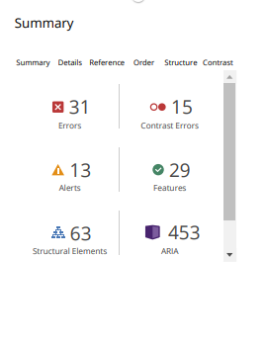

**Recommendation:**

The site does comply with standards 1.4.11 non-text Contrast (Level AA). This is because the non-text contrast is 8.59:1 which is above the minimum 3:1 color contrast ratio prescribed. see link for further reference: https://wcag.com/designers/1-4-11-non-text-contrast/